**Iris Dataset Analysis Report**

1. **Introduction**

| **Project Goal** | *Explore relationships between the Iris flower dataset features (sepal length, sepal width, petal length, petal width) and use Excel for data analysis***.** |  |
| --- | --- | --- |

1. **Dataset Overview**

| **Dataset** | **Iris Flower Dataset** |
| --- | --- |
| **Source** | *UCI Machine Learning Repository* |
| **Features** | *Sepal Length, Sepal Width, Petal Length, Petal Width* |
| **Data Cleaning** | *Checked for missing/incorrect values and handled them appropriately. Dataset was clean and ready for analysis.* |

1. **Statistical Analysis**

**3.1. Descriptive Statistics**

| **Feature** | **Mean** | **Median** | **Mode** | **Range** | **Variance** | **Standard Deviation** |
| --- | --- | --- | --- | --- | --- | --- |
| Sepal Length | 5.906667 | 6.3 | 6.5 | 2.5 | 0.712622 | 0.84417 |
| Sepal Width | 3.06 | 3.1 | 3 | 1.3 | 0.0944 | 0.307246 |
| Petal Length | 3.873333 | 4.6 | 1.4 | 4.7 | 3.340622 | 1.827737 |
| Petal Width | 1.246667 | 1.5 | 0.2 | 2.3 | 0.642489 | 0.801554 |

**3.2. Visualizations**

| **Visualization Type** | **Description** |
| --- | --- |
| **Histograms** | *Histograms were created for each feature to show their distribution*. |
| **Line Chart** | *Line chart were generated for each feature to highlight spread.* |
|  |  |

**HISTOGRAMS**

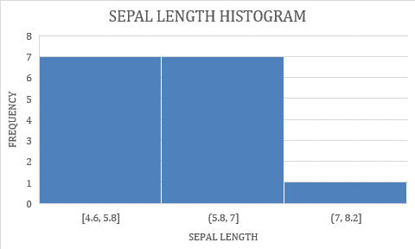

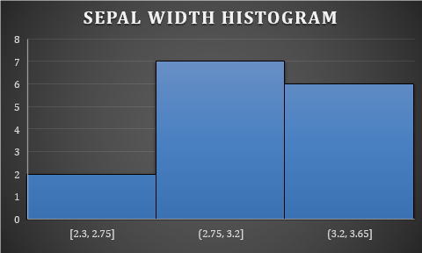

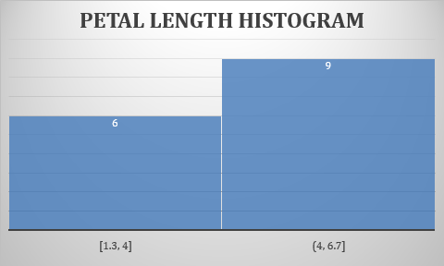

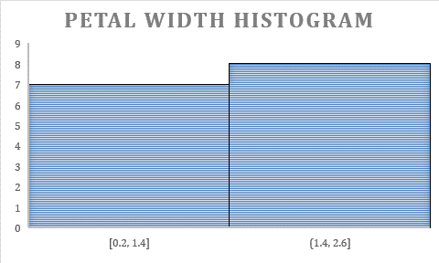

**LINE CHARTS**

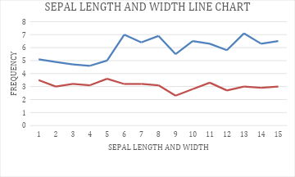

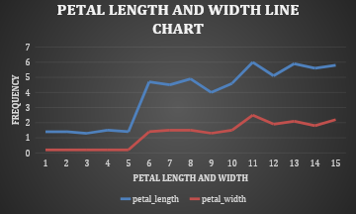

**3.3. Correlation Analysis**

| **Feature Pair** | **Correlation Coefficient** |
| --- | --- |
| Sepal Length vs. Sepal Width | -0.1609 |
| Sepal Length vs. Petal Length | 0.88545 |
| Sepal Length vs. Petal Width | 0.825179 |
| Sepal Width vs. Petal Length | -0.38179 |
| Sepal Width vs. Petal Width | -0.35787 |
| Petal Length vs. Petal Width | 0.98604 |

| **Correlation Matrix** | **Sepal Length** | **Sepal Width** | **Petal Length** | **Petal Width** |
| --- | --- | --- | --- | --- |
| **Sepal Length** | 1 | -0.1609 | 0.88545 | 0.825179 |
| **Sepal Width** | -0.1609 | 1 | -0.38179 | -0.35787 |
| **Petal Length** | 0.88545 | -0.38179 | 1 | 0.98604 |
| **Petal Width** | 0.825179 | -0.35787 | 0.98604 | 1 |

1. **Findings and Conclusion**

| **Findings** | **Key observations and patterns from the statistical analysis and visualizations.** |
| --- | --- |
| **Conclusion** | *Summary of the relationships between the features and any significant insights drawn.* |

CORRELATION IS NEGATIVE.

THE FREQUENCY OF SEPAL LENGTH IS HIGHER THAN THAT OF SEPAL WIDTH.

* **Appendices**

| **Appendix** | **Details** |
| --- | --- |
| Data Cleaning | *Log of any data cleaning steps, such as handling missing values or corrections.* |
| Excel Formulas | *List and explanation of Excel formulas used (e.g., =AVERAGE(), =MEDIAN(), =CORREL()).* |
| Visualizations | *Copies of all visualizations created during the analysis.* |

s